Terraform Basic Commands 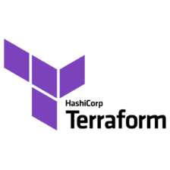

**terraform init:** this command initializes a working directory containing Terraform configuration files.

**terraform init -upgrade:** this command initialized the backend and based on the configuration files, it's determined which provider and modules it needs to pull down from the registry to allow configuration to work properly.

**terraform plan:** this command creates an execution plan, which lets you preview the changes that Terraform plans to make to your infrastructure.

**terraform apply:** this command performs a plan just like terraform plan does, but then actually carries out the planned changes to each resource using the relevant infrastructure provider's API.

**terraform validate:** this command validates the configuration files in a directory, referring only to the configuration and not accessing any remote services such as remote state, provider APIs, etc.

**terraform fmt:** this command is used to rewrite Terraform configuration files to a canonical format and style.

**terraform destroy:** this command is used to destroy the project infrastructure and free up the allocated resources.